**Name – Biswanath Singh**

**Registration no – 2023JULB01040**

**POWER BI REPORT**

**EXCEL DATA**

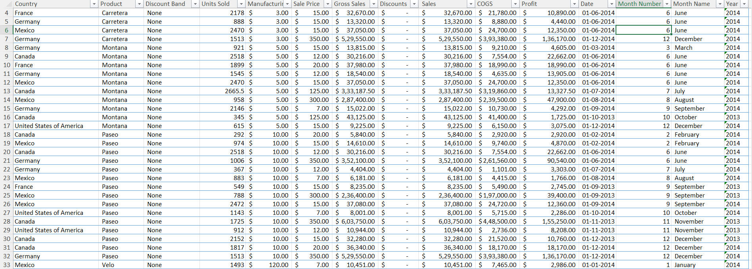

**POWERBI DASHBOARD**

**Business Analytics Pre-Report: BISWA STORES**

**1. Understanding the Problem: Unleashing Potential**

Biswa Stores is at a critical juncture. While it has achieved impressive sales and profit figures, the hidden patterns in the data can drive even greater success. The questions we aim to answer include:

* **Who are our top customers and products?**
* **Which countries and segments drive the highest profits?**
* **Where are we over-discounting, and how can we improve margins?**
* **What do our monthly sales trends reveal about customer behavior?**

These insights can transform decision-making, helping Biswa Stores grow smarter and more competitive.

**2. Data in Action: What’s on the Dashboard?**

Here’s a quick snapshot of what’s happening in the attached dashboard. Click through and explore these **interactive insights**:

1. **Global Orders by Country:**
   * **Engage with the map**: Hover over each country to see order volume and profit margin. Canada leads in orders (247K), but Germany delivers higher margins (15.7%).
2. **Segment and Product Performance:**
   * Want to see **who’s winning and who’s losing**? Click on a segment (e.g., Channel Partners) to see the breakdown of product profitability. Amarilla shines with a 73% margin, while Velo underperforms for Enterprises.
3. **Discount Distribution Insights:**
   * Pie charts come alive—explore how 57.8% of discounts fall into the “high” category. Adjust filters to see its impact on specific products or regions.

**3. Data Behind the Scenes: How We Got Here**

* **Data Collection:** Pulled directly from *Financial Sample (2)*, covering all sales, profit, orders, and discounts.
* **Data Cleaning:**
  + Removed duplicates.
  + Addressed missing fields using logical estimations.
  + Standardized all currencies and formats for consistency.
* **Validation:** All KPIs cross-verified for accuracy. For example, profit margins were re-calculated as a percentage of sales.

**4. Tools We Used to Bring It to Life**

* **Power BI:** This is your one-stop tool for exploring the dashboard. Its interactivity allows drilling into regions, segments, and products.
* **Excel & Python:** Power Query and Python scripts ensured your data was clean, validated, and ready for action.
* **Storytelling Tools:** Visual and filter-based storytelling ensure every data point tells a compelling story.

**5. Interactive Dashboard Features**

Your dashboard isn’t just static; it’s a **tool for exploration and action**:

1. **Dynamic KPIs:**
   * Click on different time periods or countries to watch the sales, profits, and margins adjust in real-time.
   * See **how discounts impact overall performance.**
2. **Time Trends:**
   * Toggle through months to identify peaks and valleys in sales.
   * Understand seasonal trends and plan promotions for peak months (e.g., June spikes).
3. **Product Insights:**
   * Want to focus on top-performing products like Paseo ($33M in sales)? Filter by product to see where they perform best geographically.
4. **Profit Margin Drill-Down:**
   * Dig deeper into the *Enterprise segment’s losses*. Use filters to isolate specific regions or products dragging down the numbers.

**6. Storytelling: What’s the Data Telling Us?**

Here’s the big picture, broken into **data-driven stories** for your business decisions:

**a. Who’s Driving Sales?**

* **Country Focus:** Canada and France lead in orders, but Germany delivers the best profit margins. Focus on scaling Germany’s operations to replicate its efficiency.
* **Segment Analysis:** Channel Partners outperform across the board (73% profit margin). Invest in strengthening relationships and resources here.

**b. What About Our Products?**

* Paseo is the undisputed champion. But **Velo** and **Amarilla** are dragging down the Enterprise segment. It’s time to revisit pricing and promotion strategies for these products.

**c. Are We Over-Discounting?**

* High discounts (57.8%) dominate the strategy—but are they necessary? Drill into specific products (e.g., Montana) to see if discounts align with their sales performance.

**d. Seasonal Sales Trends:**

* Sales peak during certain months (e.g., May and June). Capitalize on these trends with timely campaigns while addressing off-peak dips.

**7. Next Steps for Engagement**

Here’s how you can use the dashboard to make informed, strategic decisions:

1. **Optimize Discounts:**
   * Use the profit margin vs. discount filters to find the sweet spot—maximizing sales without over-discounting.
2. **Revive Enterprise Segment:**
   * Focus on products like Carretera and Velo to plug profit leaks in the Enterprise category.
3. **Focus on Efficiency:**
   * Invest more resources in Germany and explore replicating its high-margin strategy in the U.S. and Mexico.
4. **Plan Ahead for Seasonal Trends:**
   * Develop campaigns targeting the months when sales naturally spike.